Individual Summary Report

Key Development Contributions

HTML & CSS:

I undertook the design and layout for the context pages, Relic 1 pages and Relic 4 pages. This involved creating each HTML & CSS page in the project to guarantee a responsive and aesthetically pleasing layout throughout the game.

I’ve placed some examples of my work below:

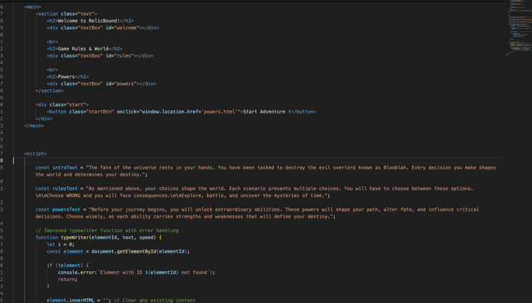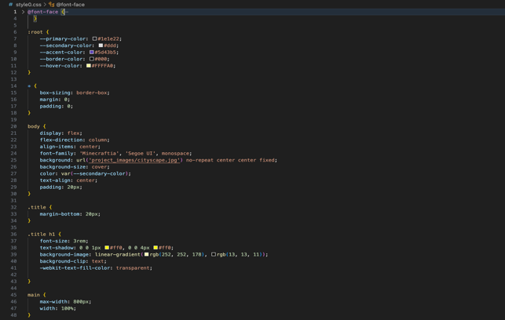

Context Page 1

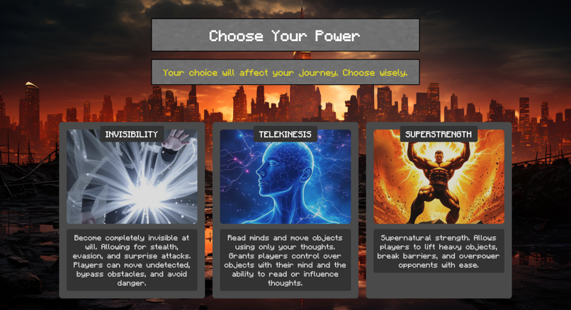

Powers Page

JAVASCRIPT:

I implemented interactive elements to better enhance a player’s experience this included:
- Navigation which depends on player choice
- Interactive Puzzles using Java Timed Events e.g. Sword Puzzle & Cryptography puzzle.
- Visibility toggles & DOM Manipulation to enhance interactivity.

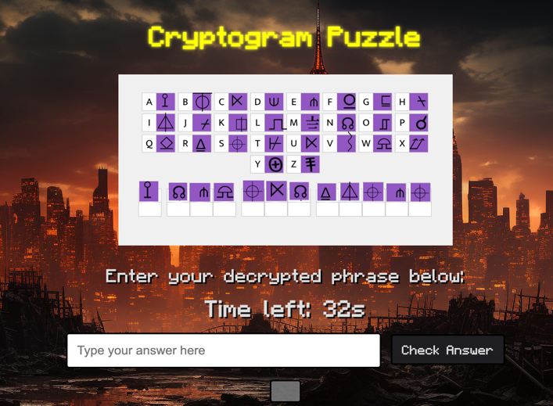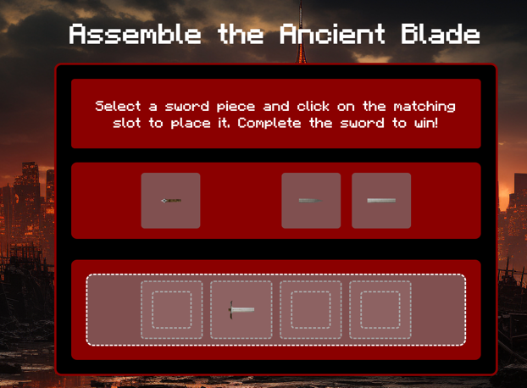

Cryptogram Puzzle Sword Puzzle

Database & SQL:
- Throughout the game there are multiple scenarios where player will have to decide between choices of powers, which they have previously selected comes into play. I was the one who implemented the insertion and retrieval of powers from our gameTable in SQL

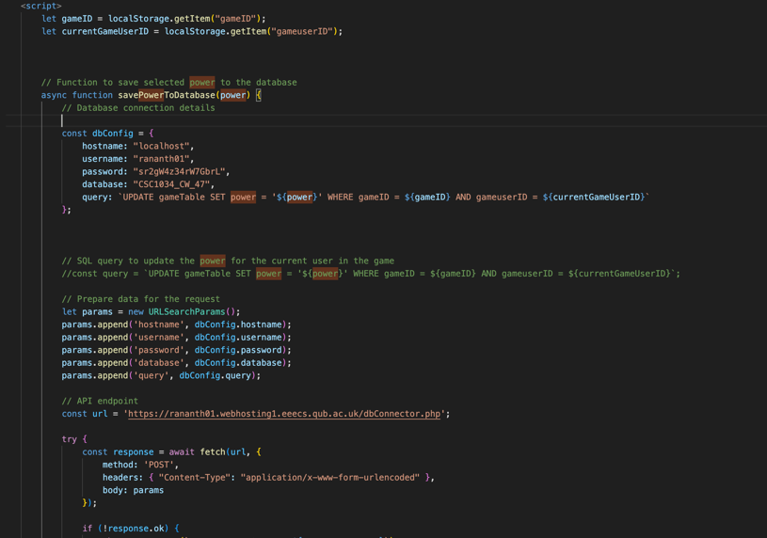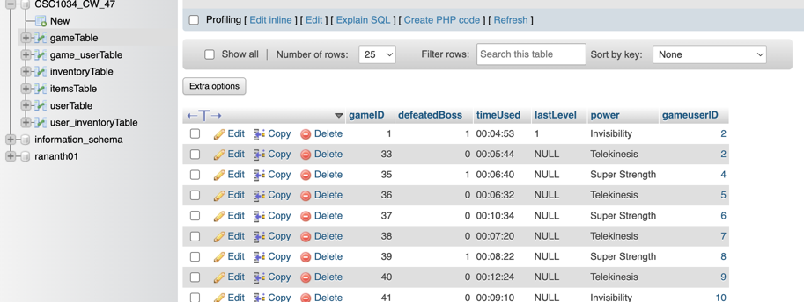

Technical Complexity & UX Enhancements:

There were some feature of the game that were quite difficult to one of these included

Global Statistics:

The globalstats.html page presents live-updating aggregate data such as:

1.Most Popular Power Choice. 2.Ratios of success to failure per power.

3.Number of game completions 4. Average Play Times

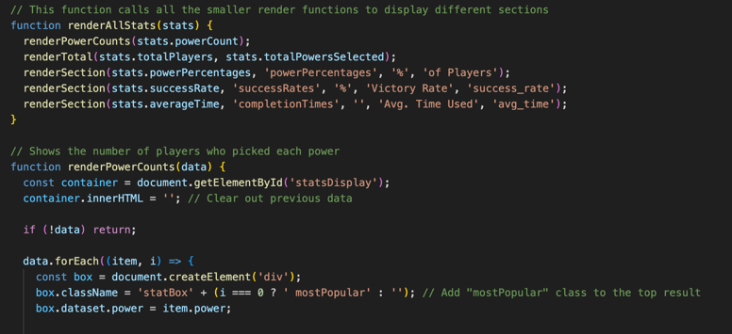

Asynchronous Data Loading:
- Implemented this using JS fetch API as it was important to get real-time data from the database for pages such as global stats and even retrieving chosenPower from the gameTable

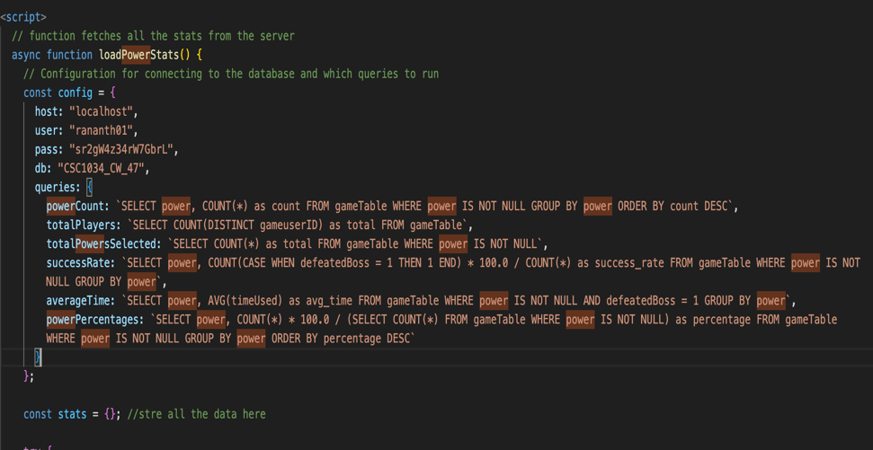

Generative AI

- I used AI resources throughout the project, mainly as an insight rather than me copying down everything it wrote. I would use it for e.g. for coming up with new CSS animations and layout options. Asking advice on SQL especially for some pages such as the globalStats page. Nevertheless all the code I’ve used has been written/integrated by me.

